**QUIZ RESULTS**

**MODULE2: DATA SPLIT AND POLYNOMIAL REGRESSION**

|  |  |  |  |  |
| --- | --- | --- | --- | --- |
| **No.** | **Quiz title** | **Completion Status** | **Score** | **Coursera link** |
| 1 | Module2_Practice Quiz_ Training and Test Splits | Completed | 100% | [Quiz 1](https://www.coursera.org/learn/supervised-machine-learning-regression/assignment-submission/KtlmV/practice-quiz-training-and-test-splits) |
| 2 | Module2_Practice Quiz_ Polynomial Regression | Completed | 100% | [Quiz 2](https://www.coursera.org/learn/supervised-machine-learning-regression/assignment-submission/2g6M3/practice-quiz-polynomial-regression) |
| 3 | Module2_Data Splits and Polynomial Regression | Completed | 100% | [Quiz 3](https://www.coursera.org/learn/supervised-machine-learning-regression/assignment-submission/zHRgJ/module-2-graded-quiz-data-splits-and-polynomial-regression) |

# Module2_Practice Quiz_ Training and Test Splits

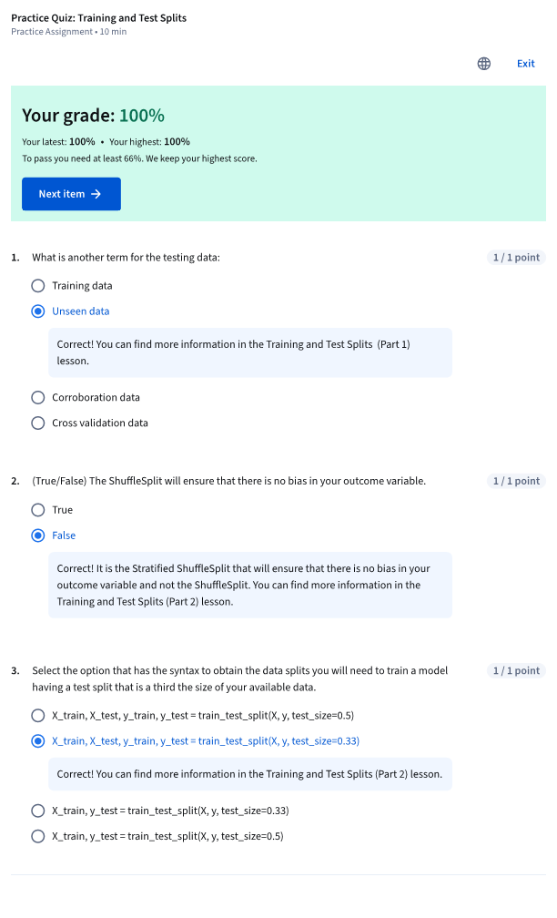

# Module2_Practice Quiz_ Polynomial Regression

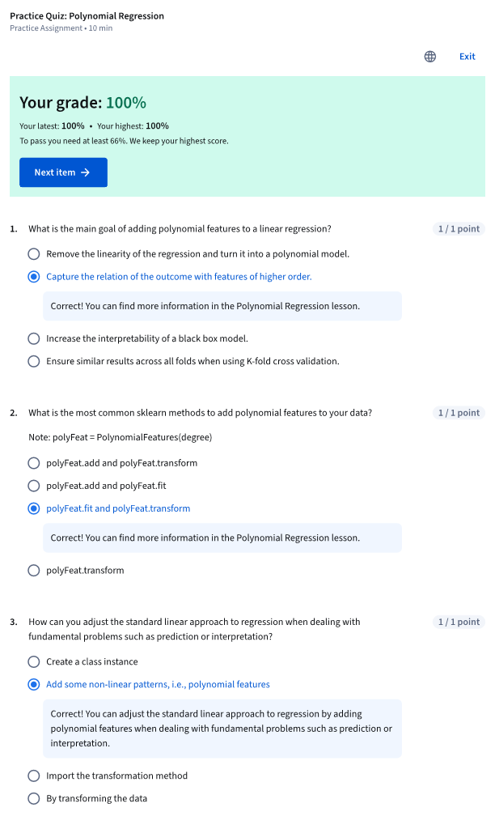

# Module2_Data Splits and Polynomial Regression

